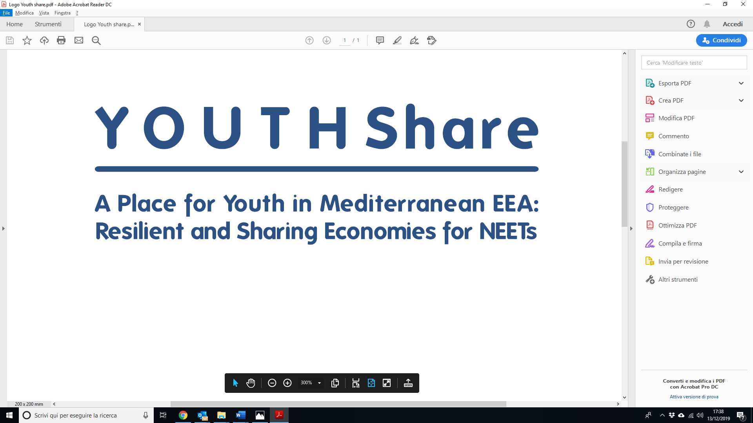

**MANAGING ORGANIZATION |** CARDET

Address: Lykavitou Avenue 29, 1st Floor, 2041 Nicosia Tel: 22 002108

[jobs@cardet.org](mailto:jobs@cardet.org) www.cardet.org

***ANNEX 1 – Application form template***

**Posting Title:** Youth Liaison- Key Account Manager

**Posting Period:** 20 December 2019 – 17 January 2020

**CALL OF EXPRESSION OF INTEREST - APPLICATION FORM**

1. **GENERAL INFORMATION**

|  |  |
| --- | --- |
| **First Name** |  |
| **Last Name** |  |
| **Date of Birth** |  |
| **Address** |  |
| **Phone** |  |
| **E-mail** |  |

1. **MANDATORY REQUIREMENTS**

|  |  |
| --- | --- |
| **Degree** | *Specify University, Faculty, Date and Final Grade* |
| **Master Degree** | *Specify University, Faculty, Date and Final Grade* |
| **English level[1]** | *Specify the English level according to the Common European Framework of Reference for Languages* |

1. **DECLARATIONS**

I hereby declare that:

* I am aware that I am applying to a call for expression of interest and not to a binding employment process;
* I have read the call for expression of interest and I have understood the terms of references;
* I have understood the evaluation process and I am aware that CARDET might not hire anybody at the end of the recruitment process;
* The information provided is true and correct;
* I give my consent to the processing of personal data for the sole purposes related to the management of the recruitment, in relation to the Legislative Decree no. 196/2003 et seq. mm. ii. and EU Regulation no. 2016/679.

1. **ANNEXES**

* Curriculum Vitae in English;
* Cover letter in English;
* Other: _________________________________

Place and date

|  |  |  |
| --- | --- | --- |
|  |  | Name and Surname  **____________________________** |

SIGNATURE

1. English language requirement: C2